**APIM**

API management helps organization publish API to external partners and internal developer to unlock potential of their data and services.

It is gateway service. API which we are going to use are hosted any where in on premises or azure app service or any third party service.

Developer need to sign in for API after that they given subscription key with this key they use API key

We can get insight of usage.

**Benefit of API Management:**

Work with any host, API and scale

Attract more developer

Secure and optimize your API

Gain insight into API

* Administrator create API. Each API consist one or more operation(get,put,post).each api can b added to one or more product.to use an API developer subscribe product that contains API then call API operations

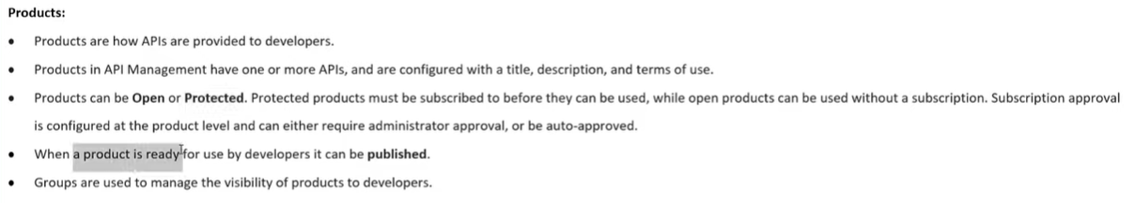

Groups:

* Administrator: it manage API management service instance, create API , operations and product that used by developer
* Developer: Authenticated developer portal user fall in to this group. build application that call the operation of API
* Guest: Unauthenticated developer portal user they can be granted certain read only access



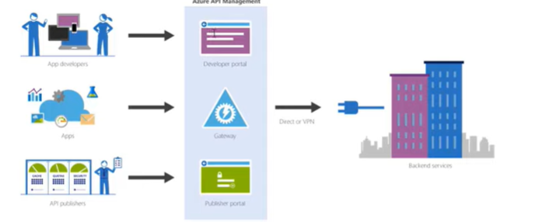

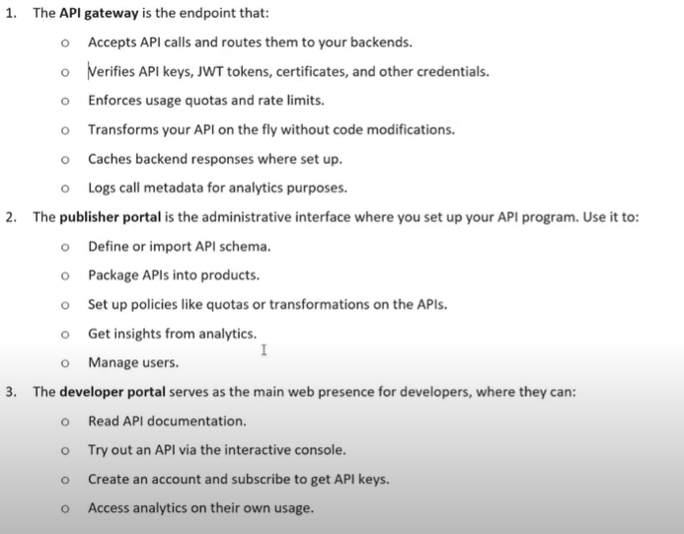

API management is front end on API to monitor, usage etc.

Create APIM:

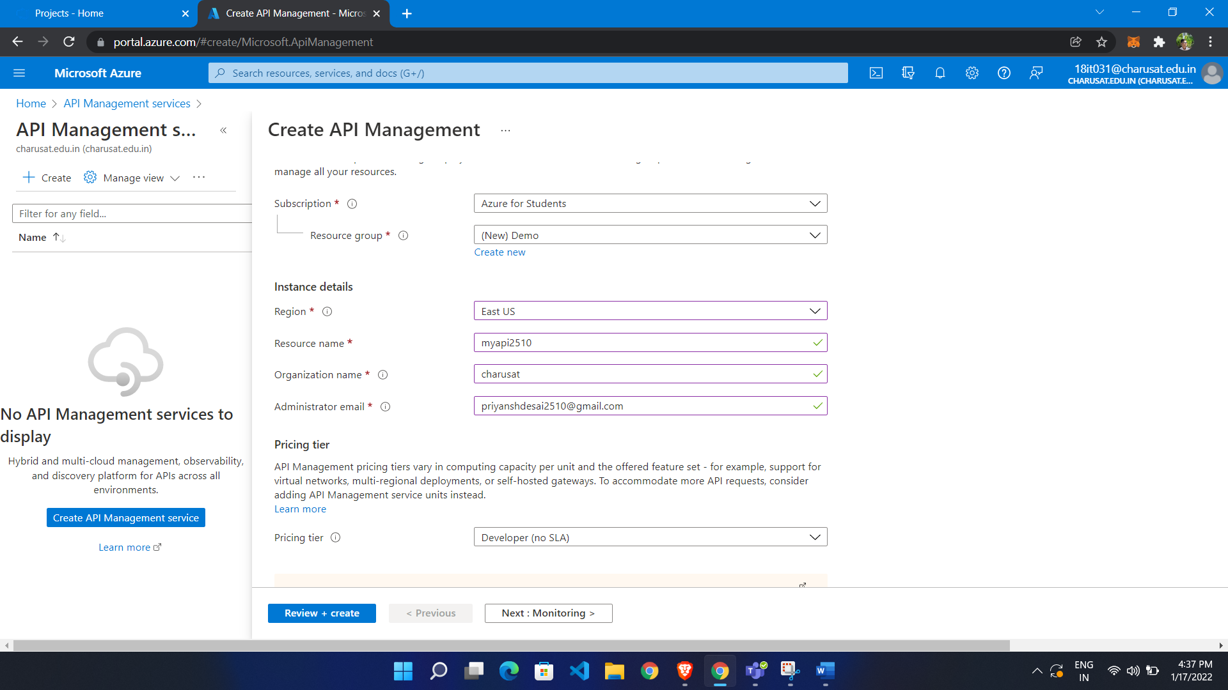

Add open API

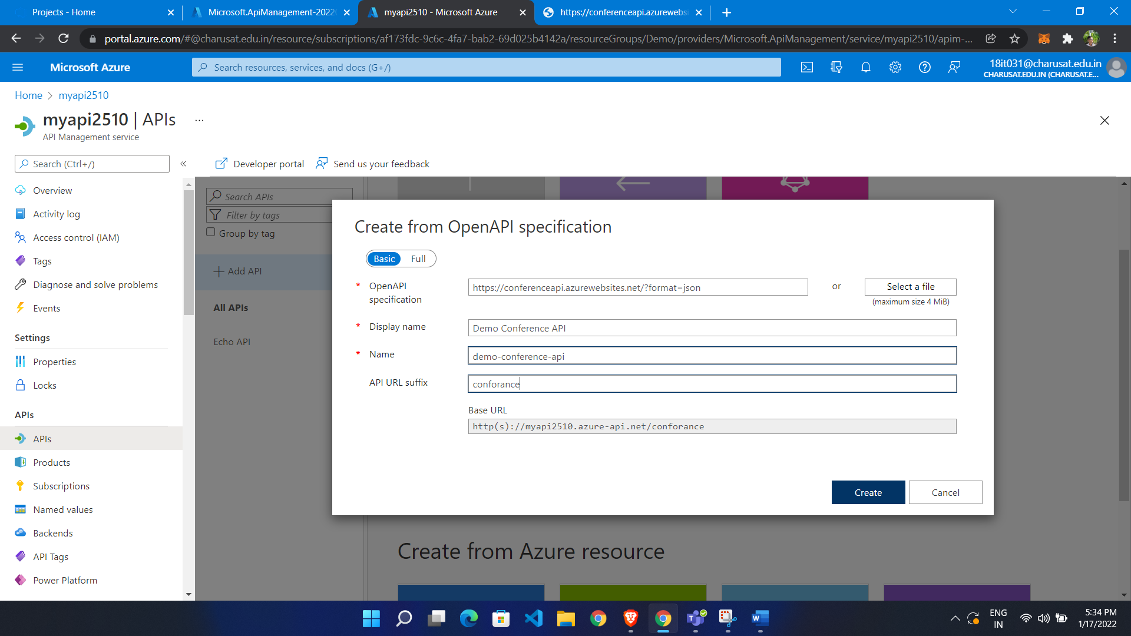

It is base API

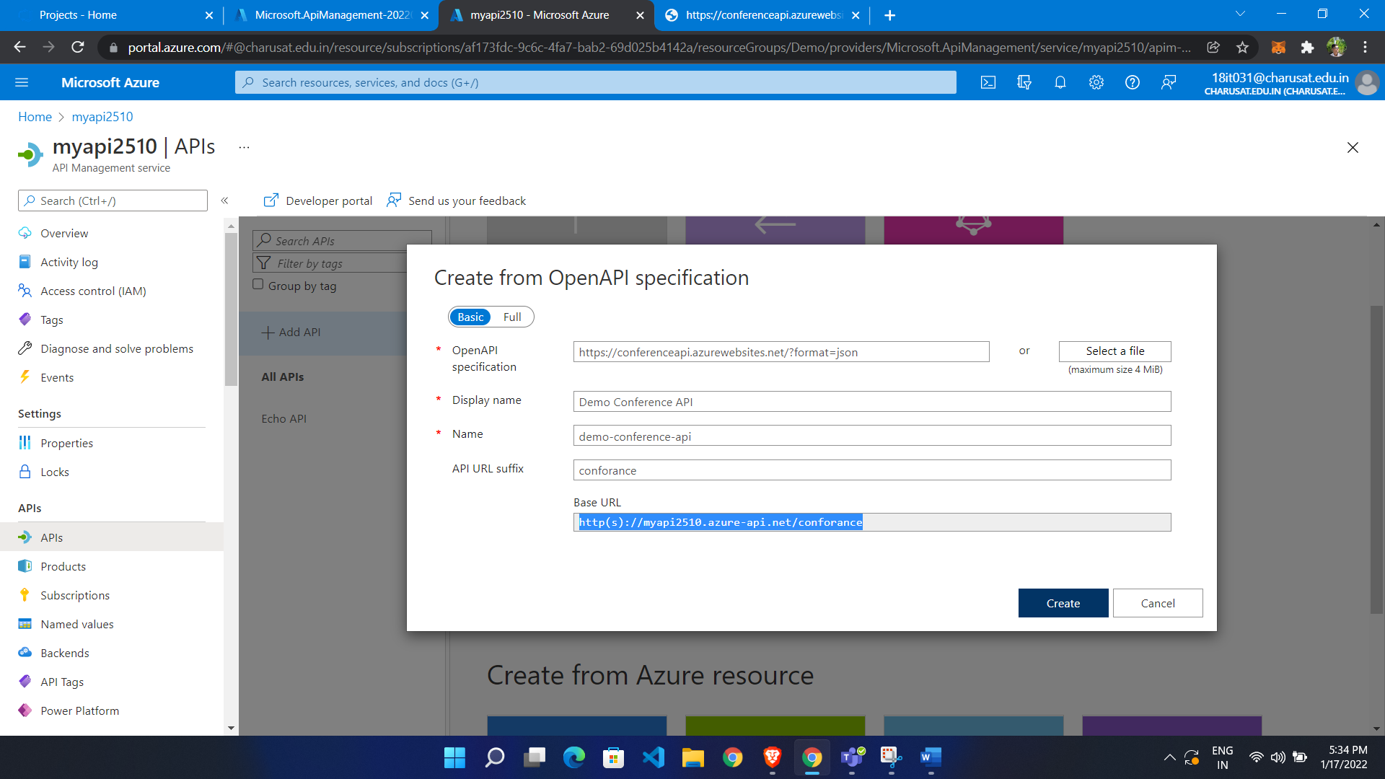

Add products

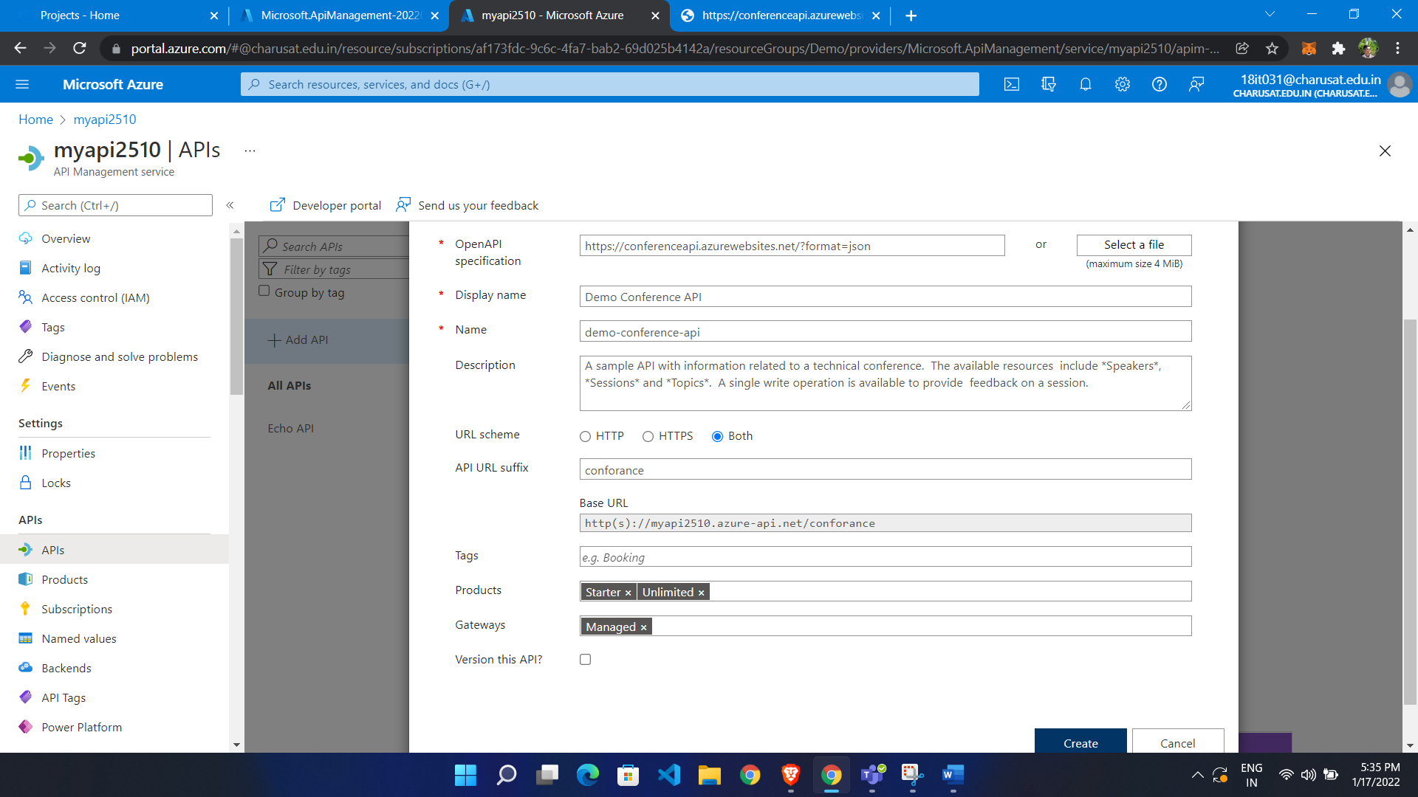

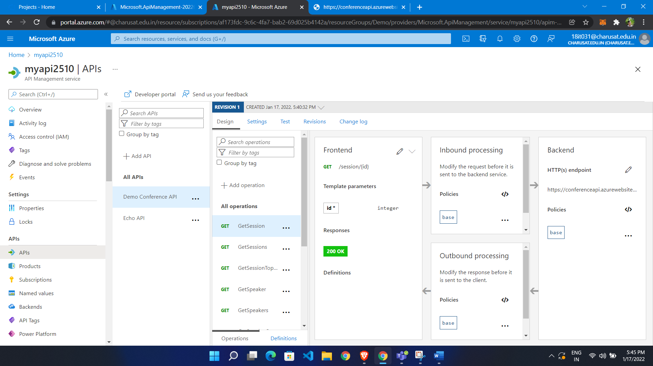

We can test API

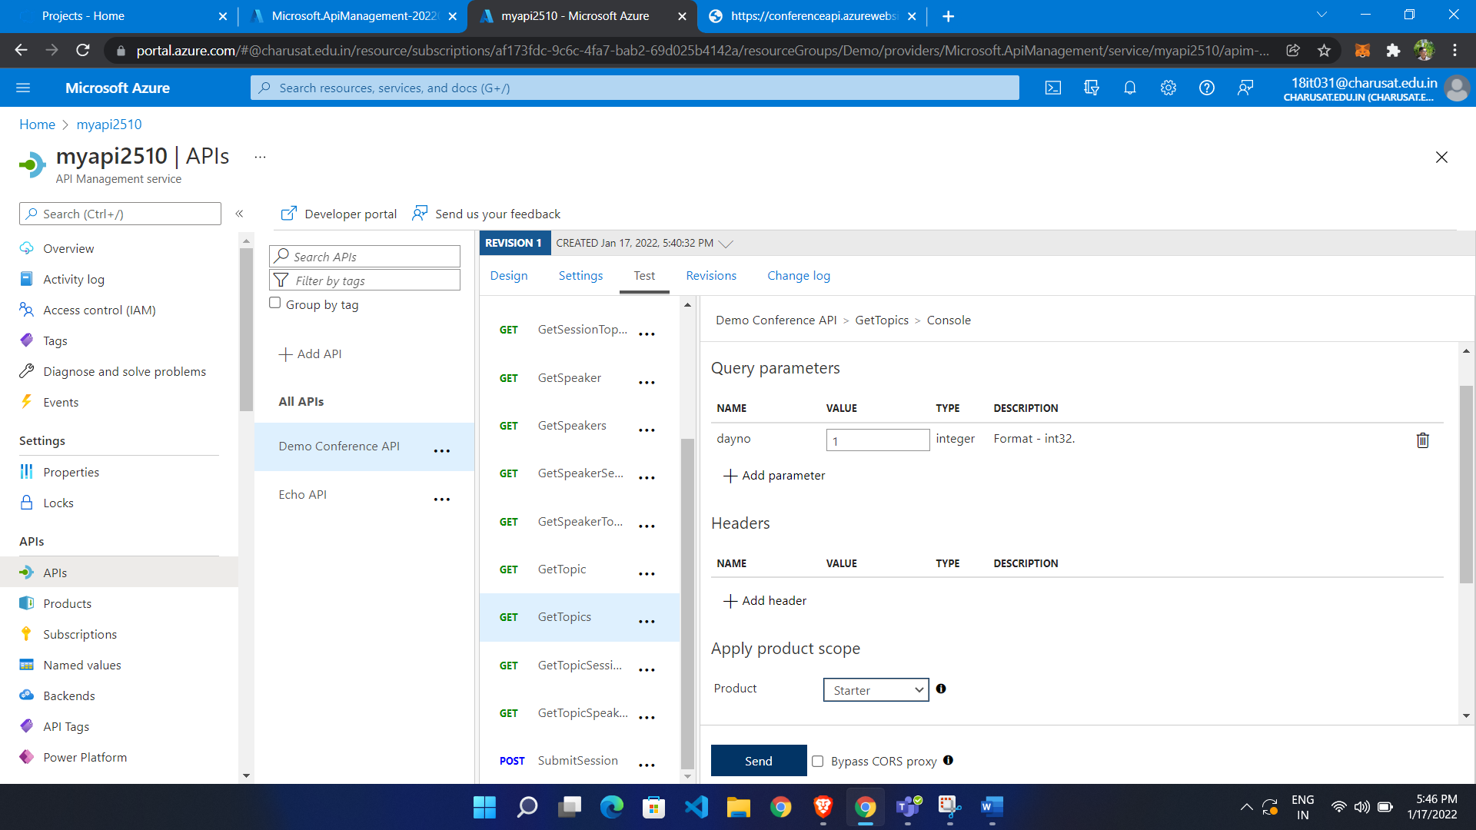

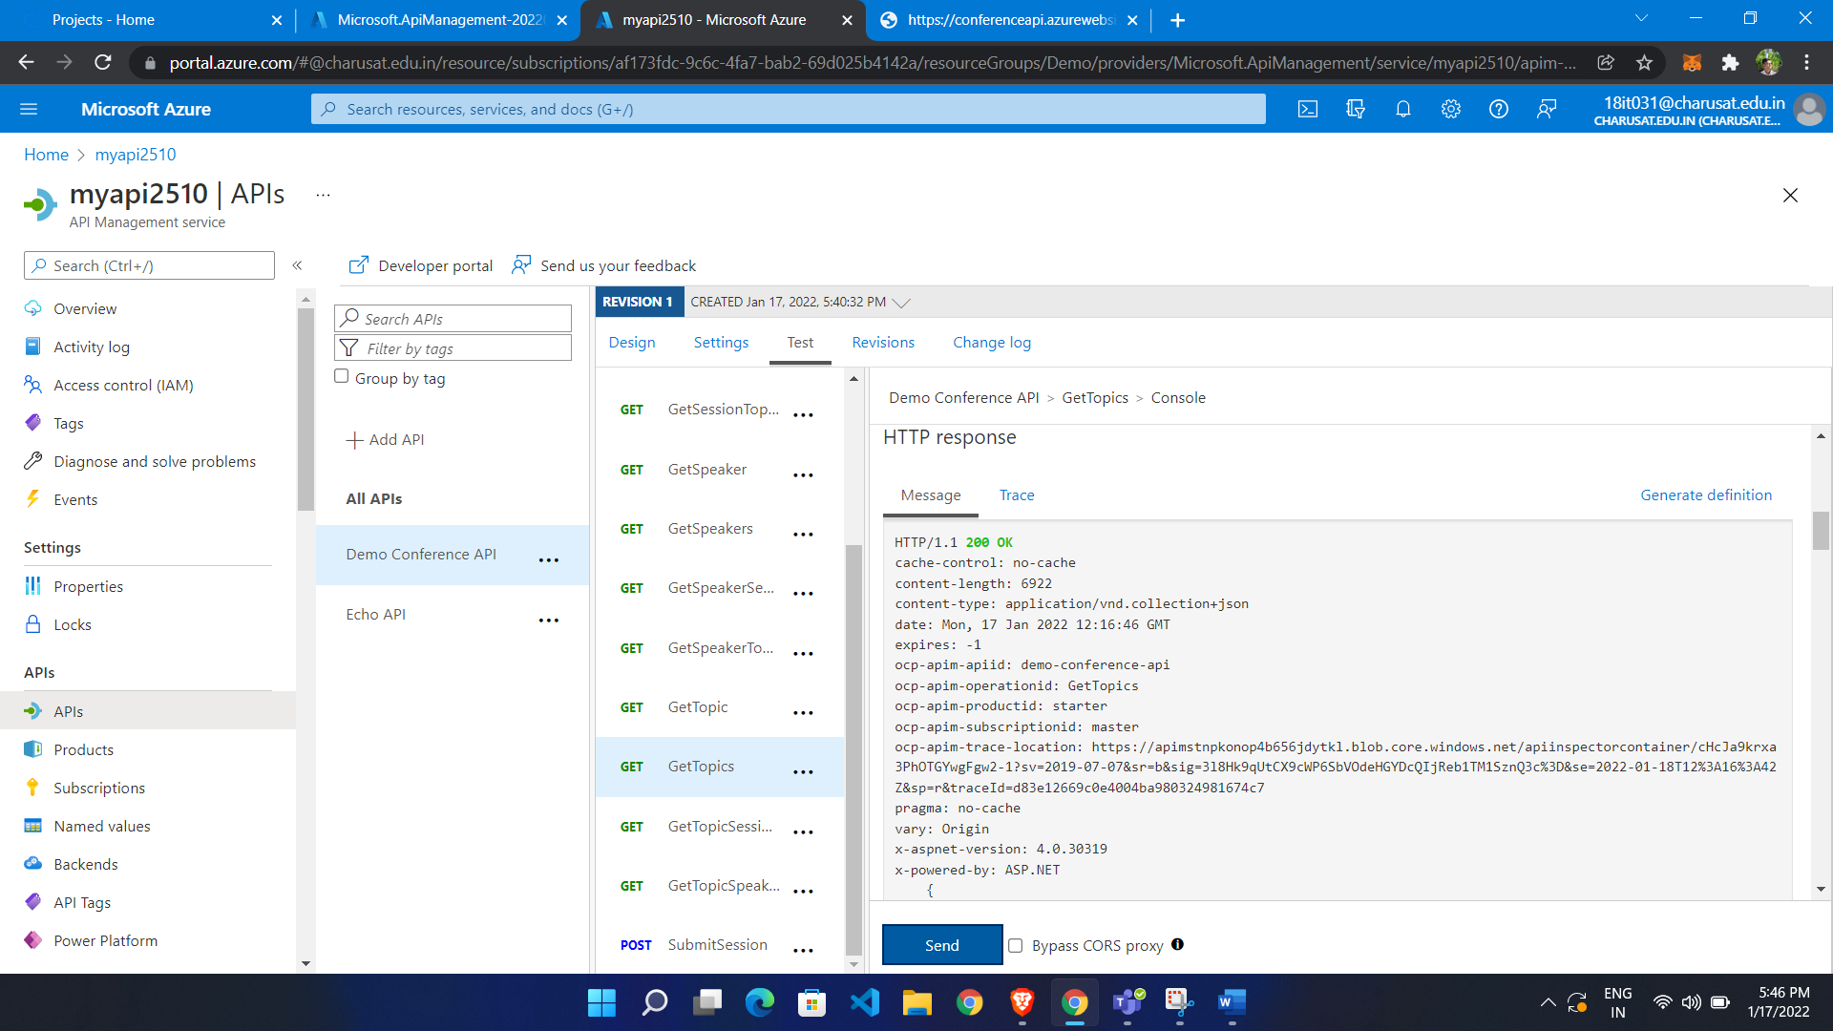

Add subscriber to access the API:

Developer portal

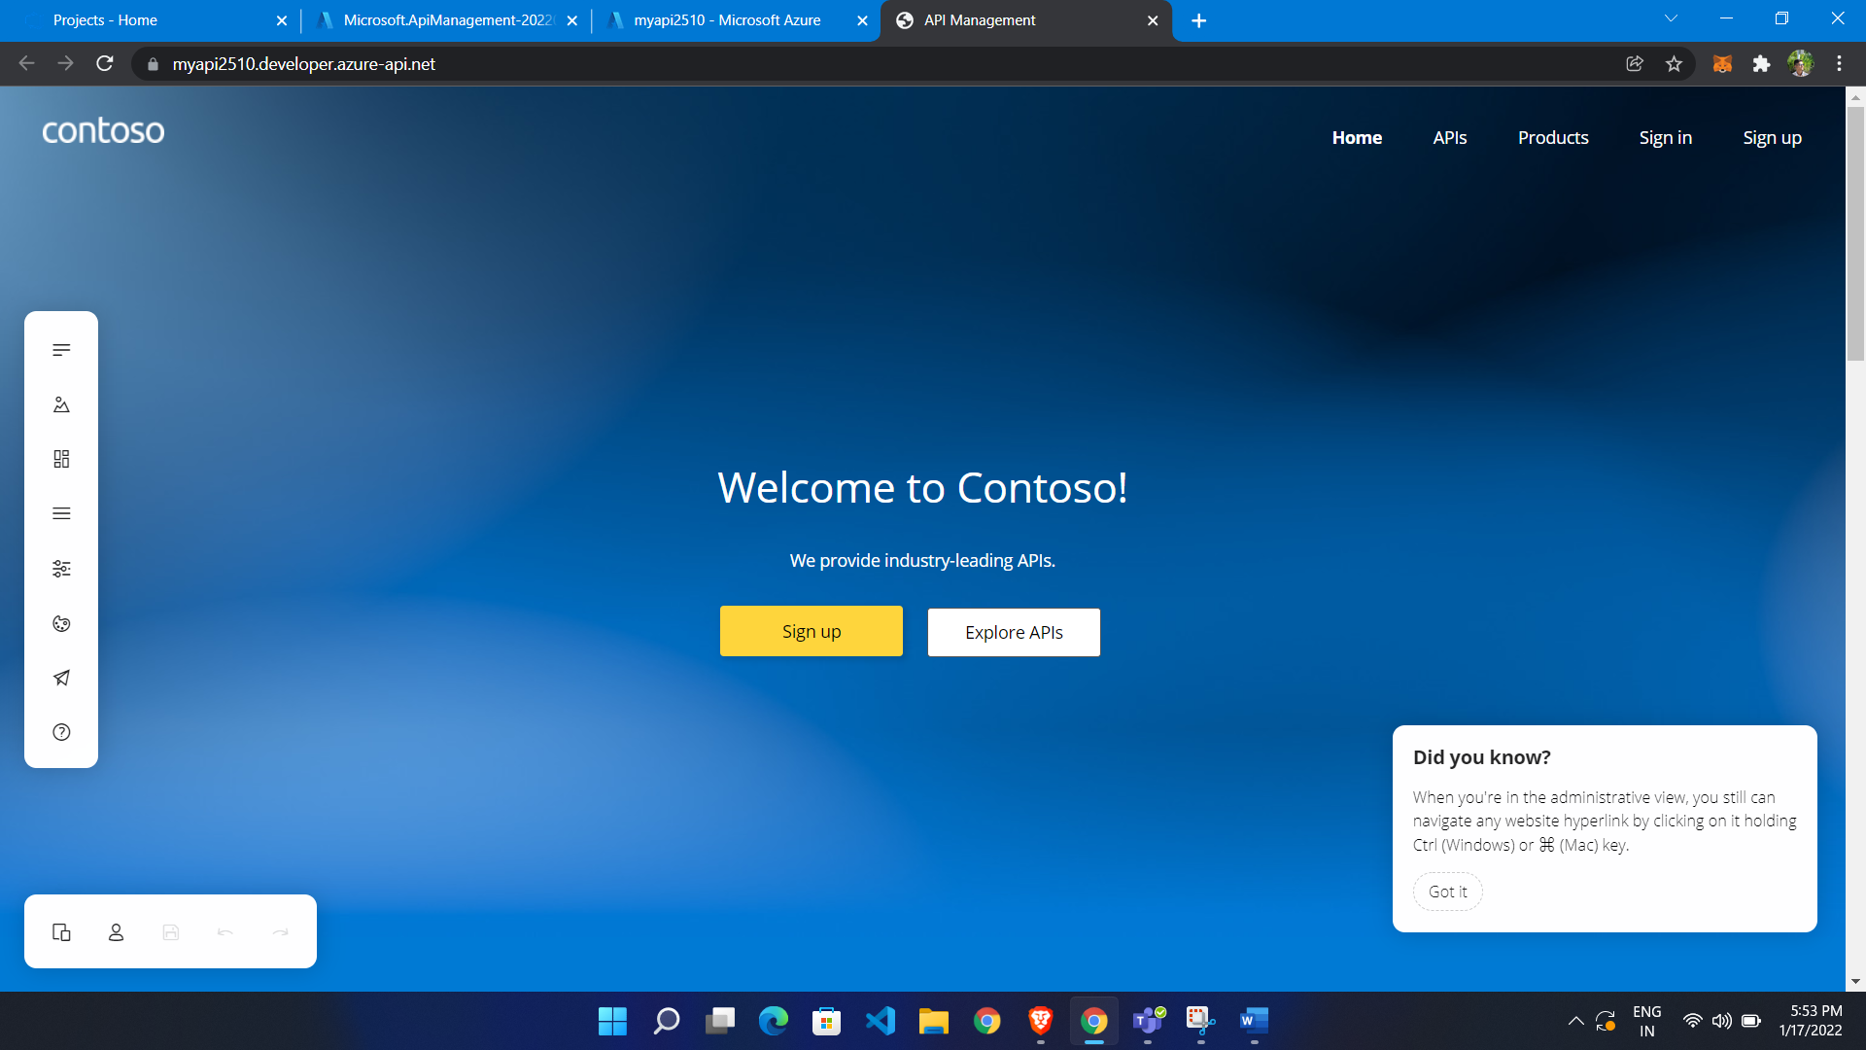

Make change what you have to done and publish

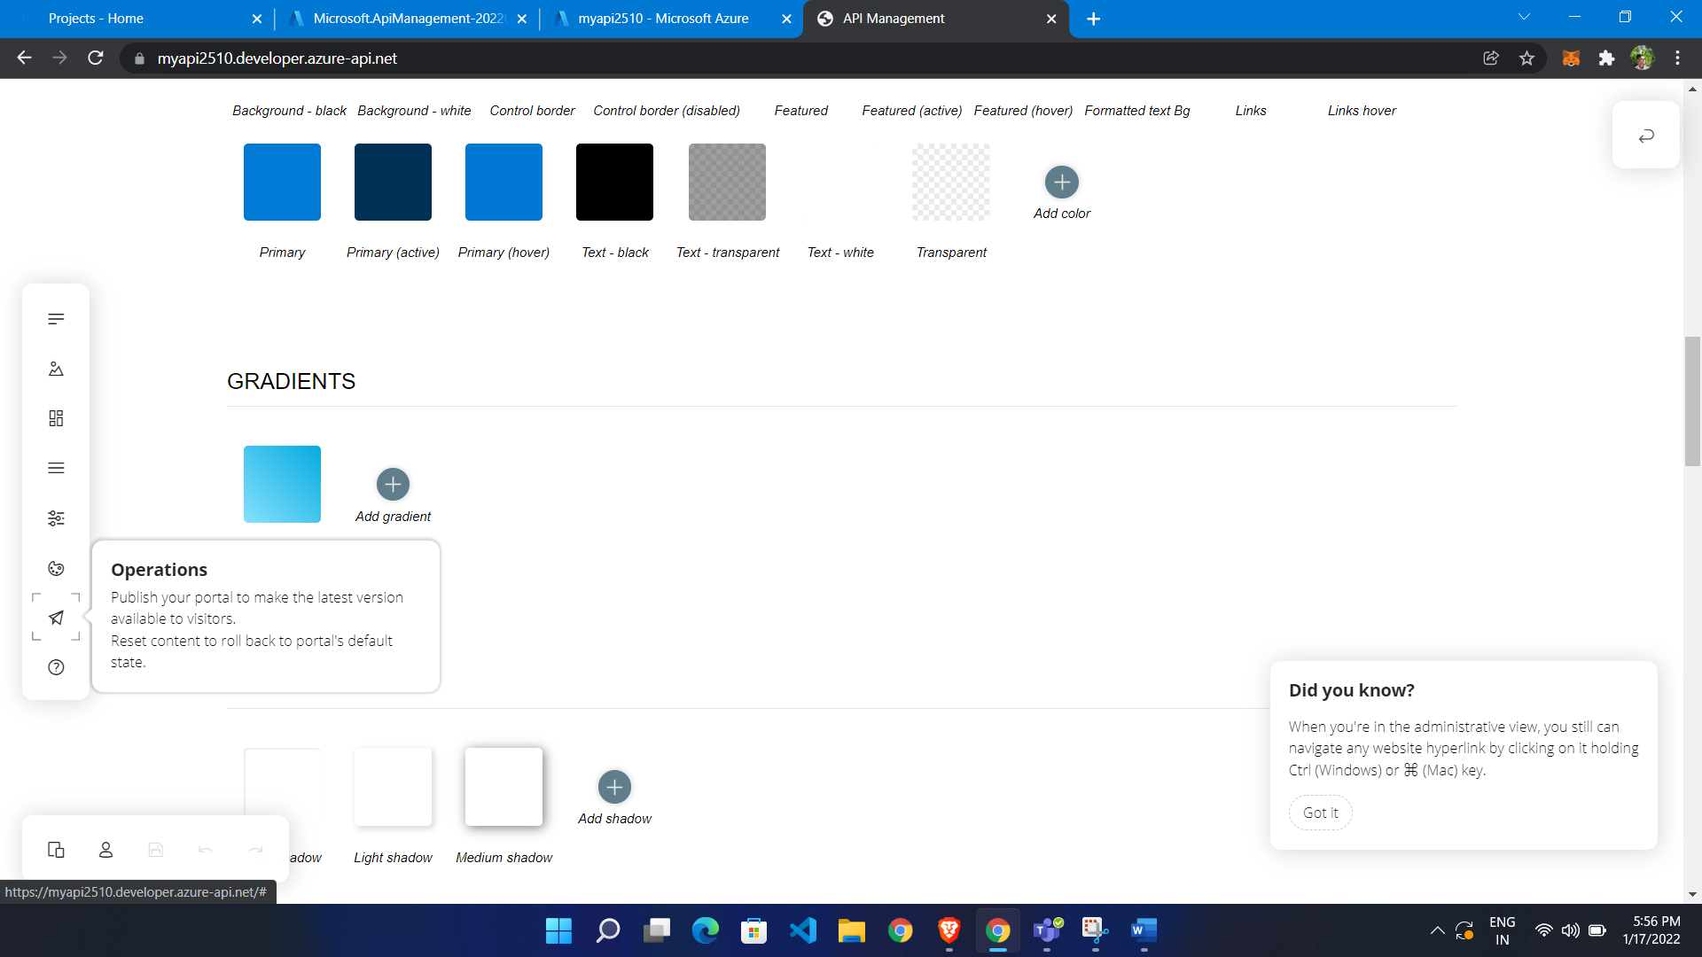

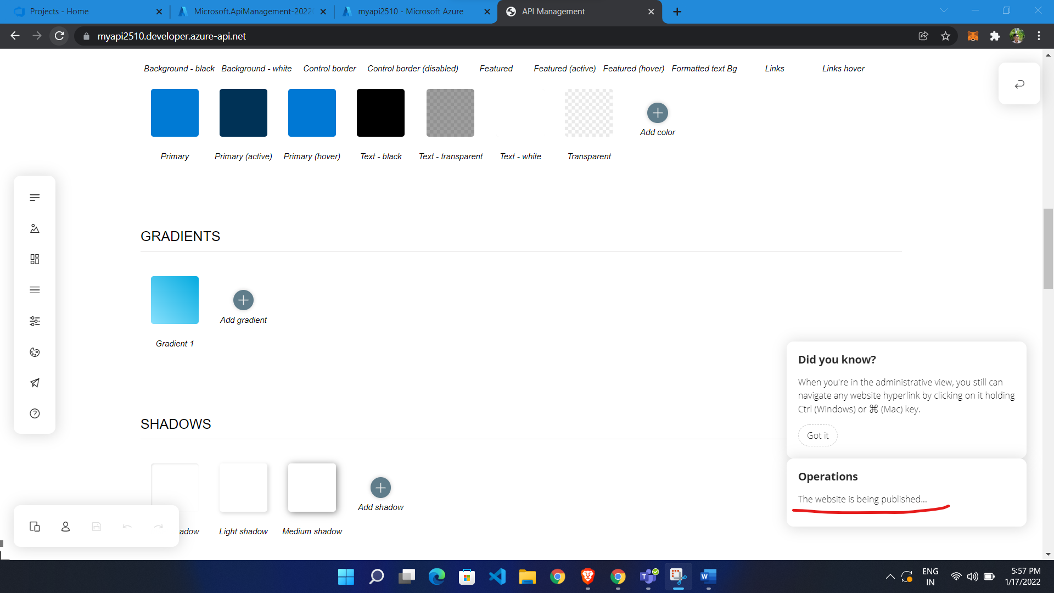

Now open in incognito so by default we are not logged in so our role is guest:

As a guest we can see API , products

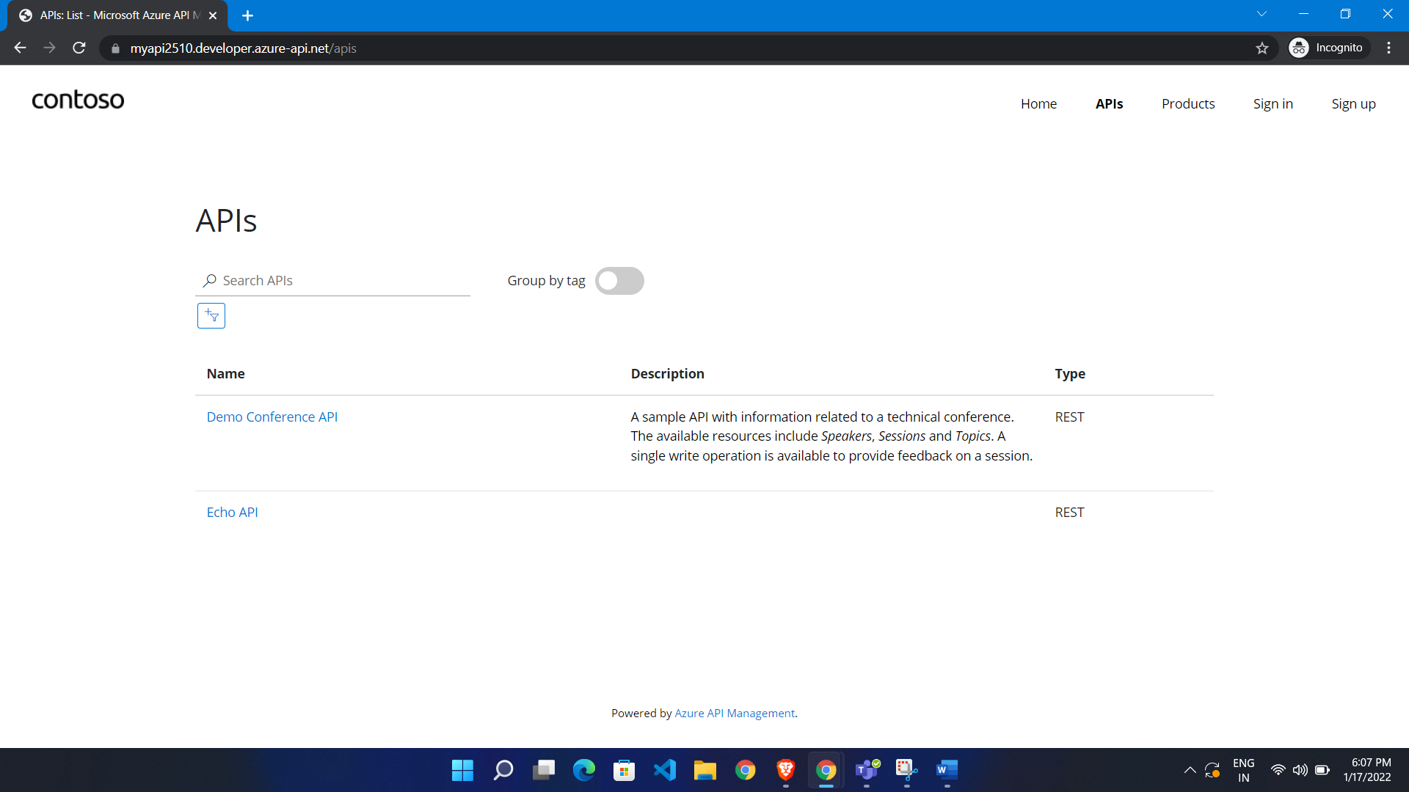

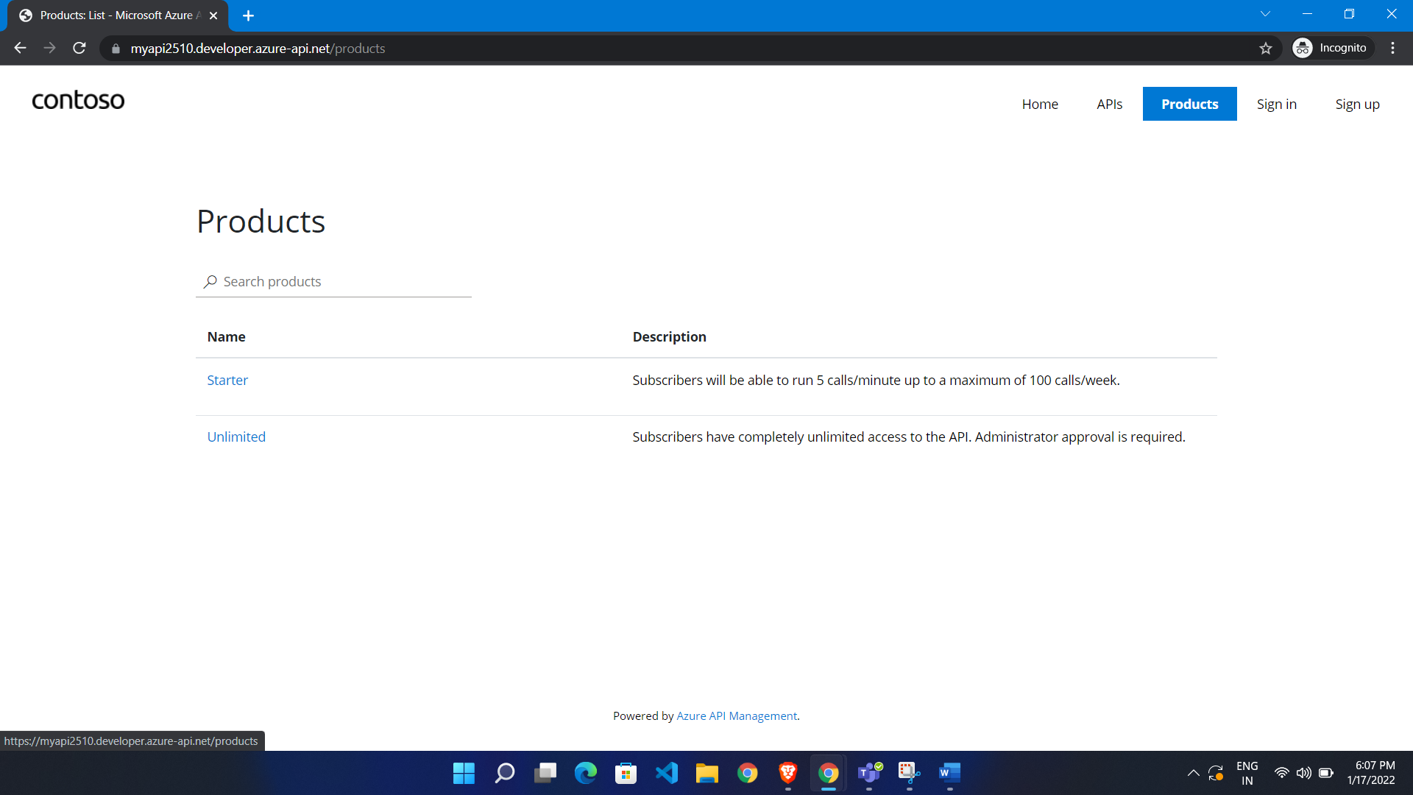

Add new user so we sign up

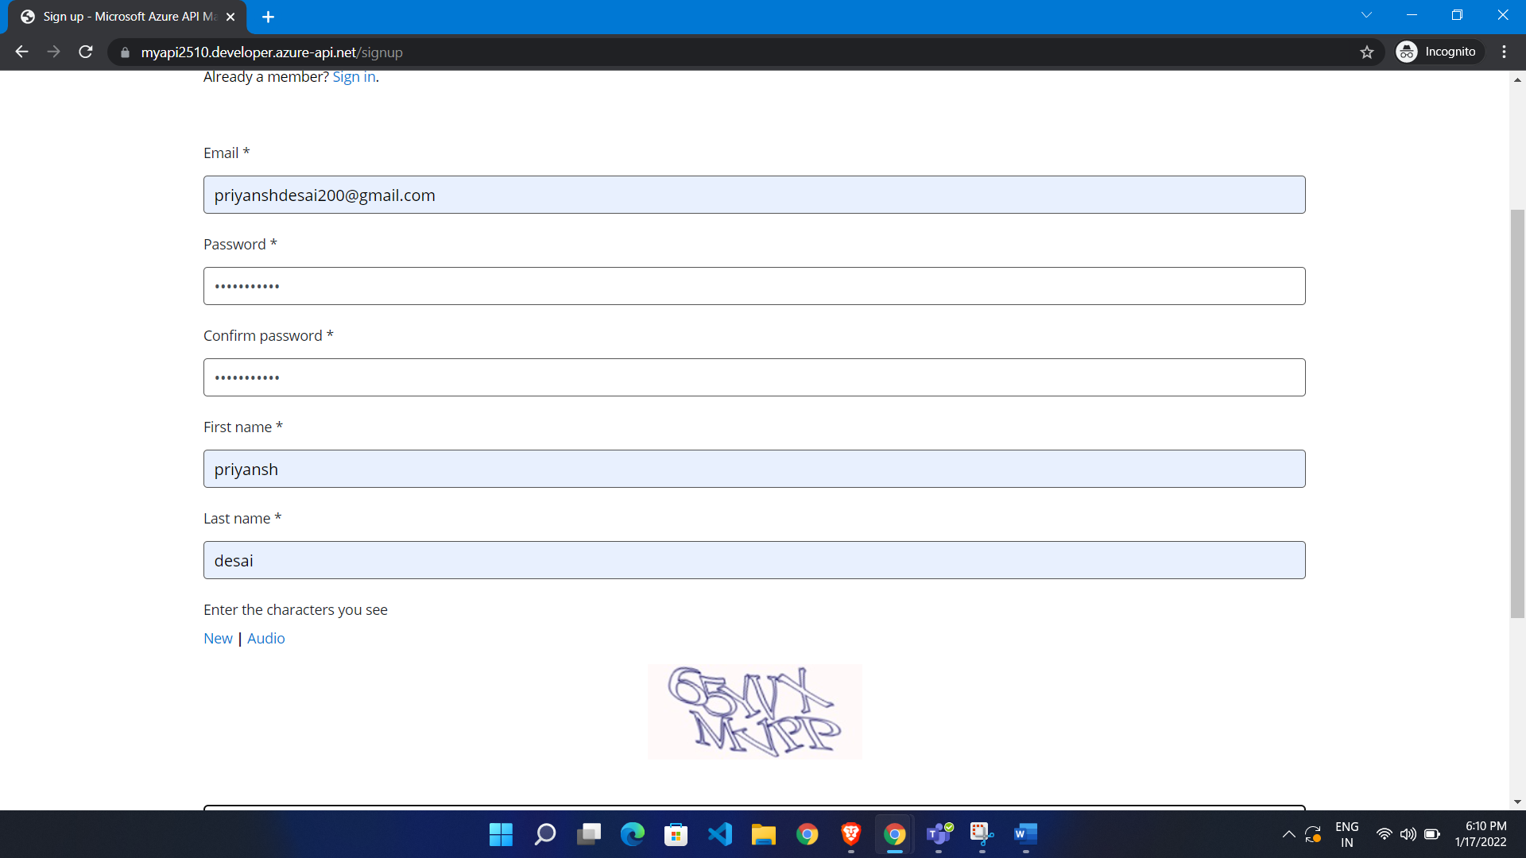

Now we see new user added

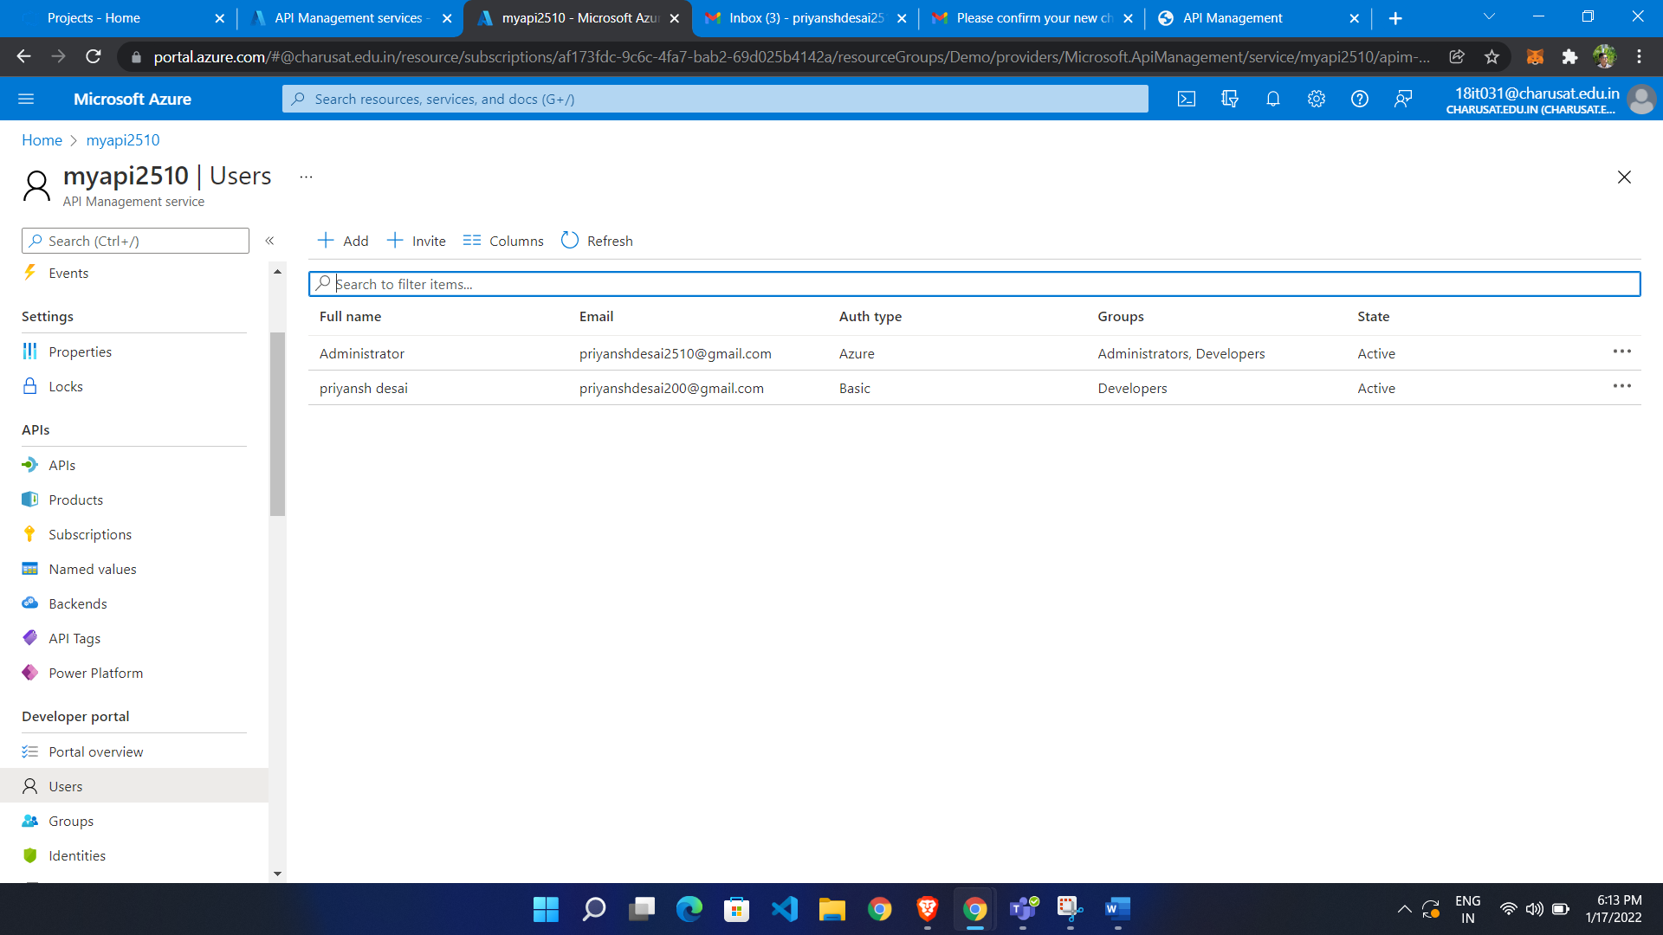

Subscribe user:

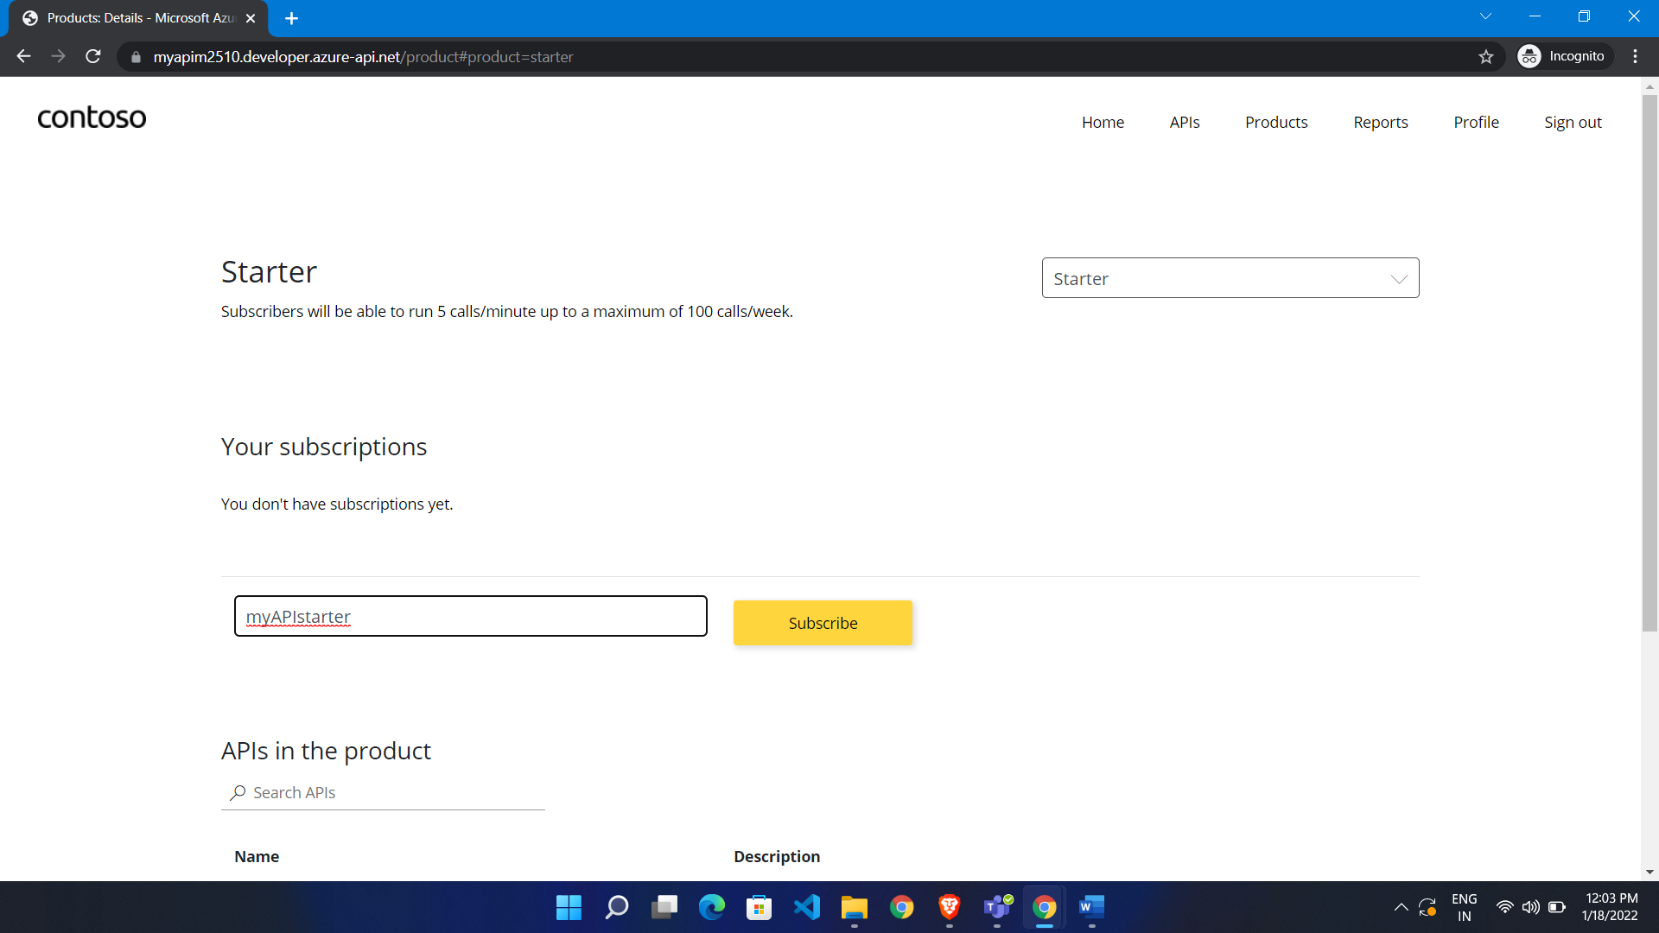

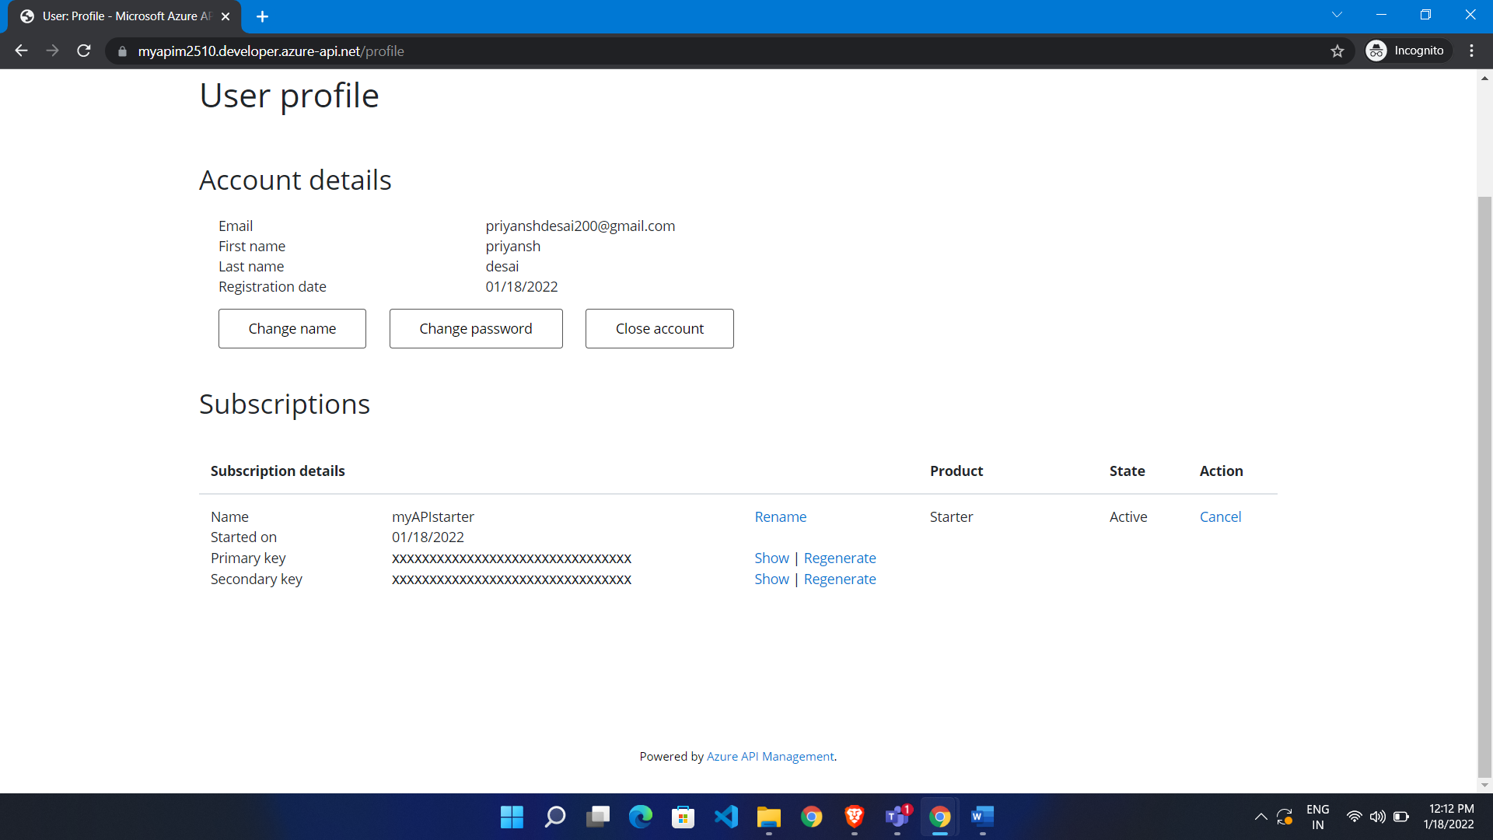

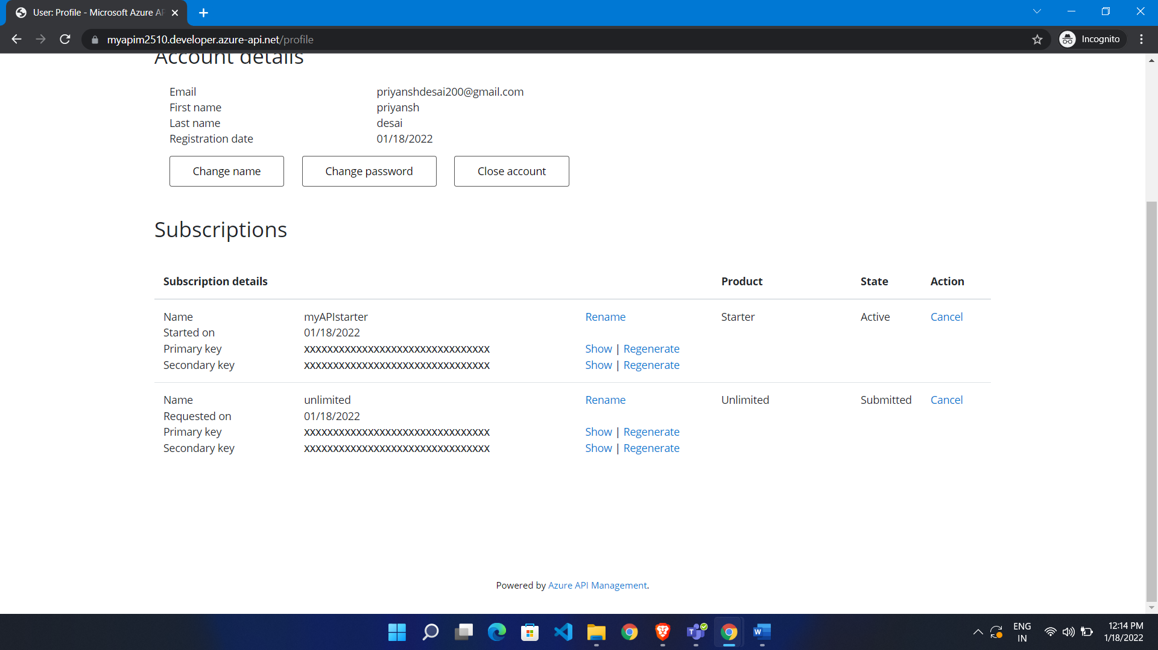

Now it is submitted and we need to approve

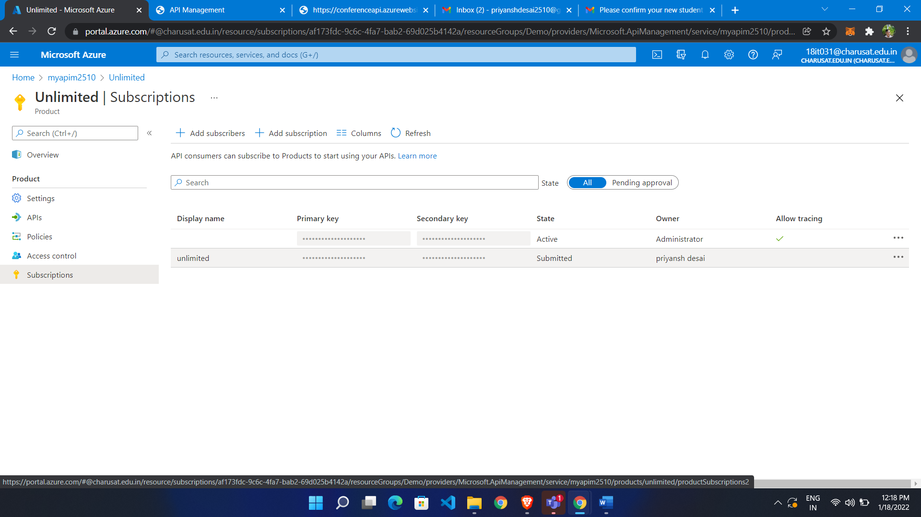

Both activated

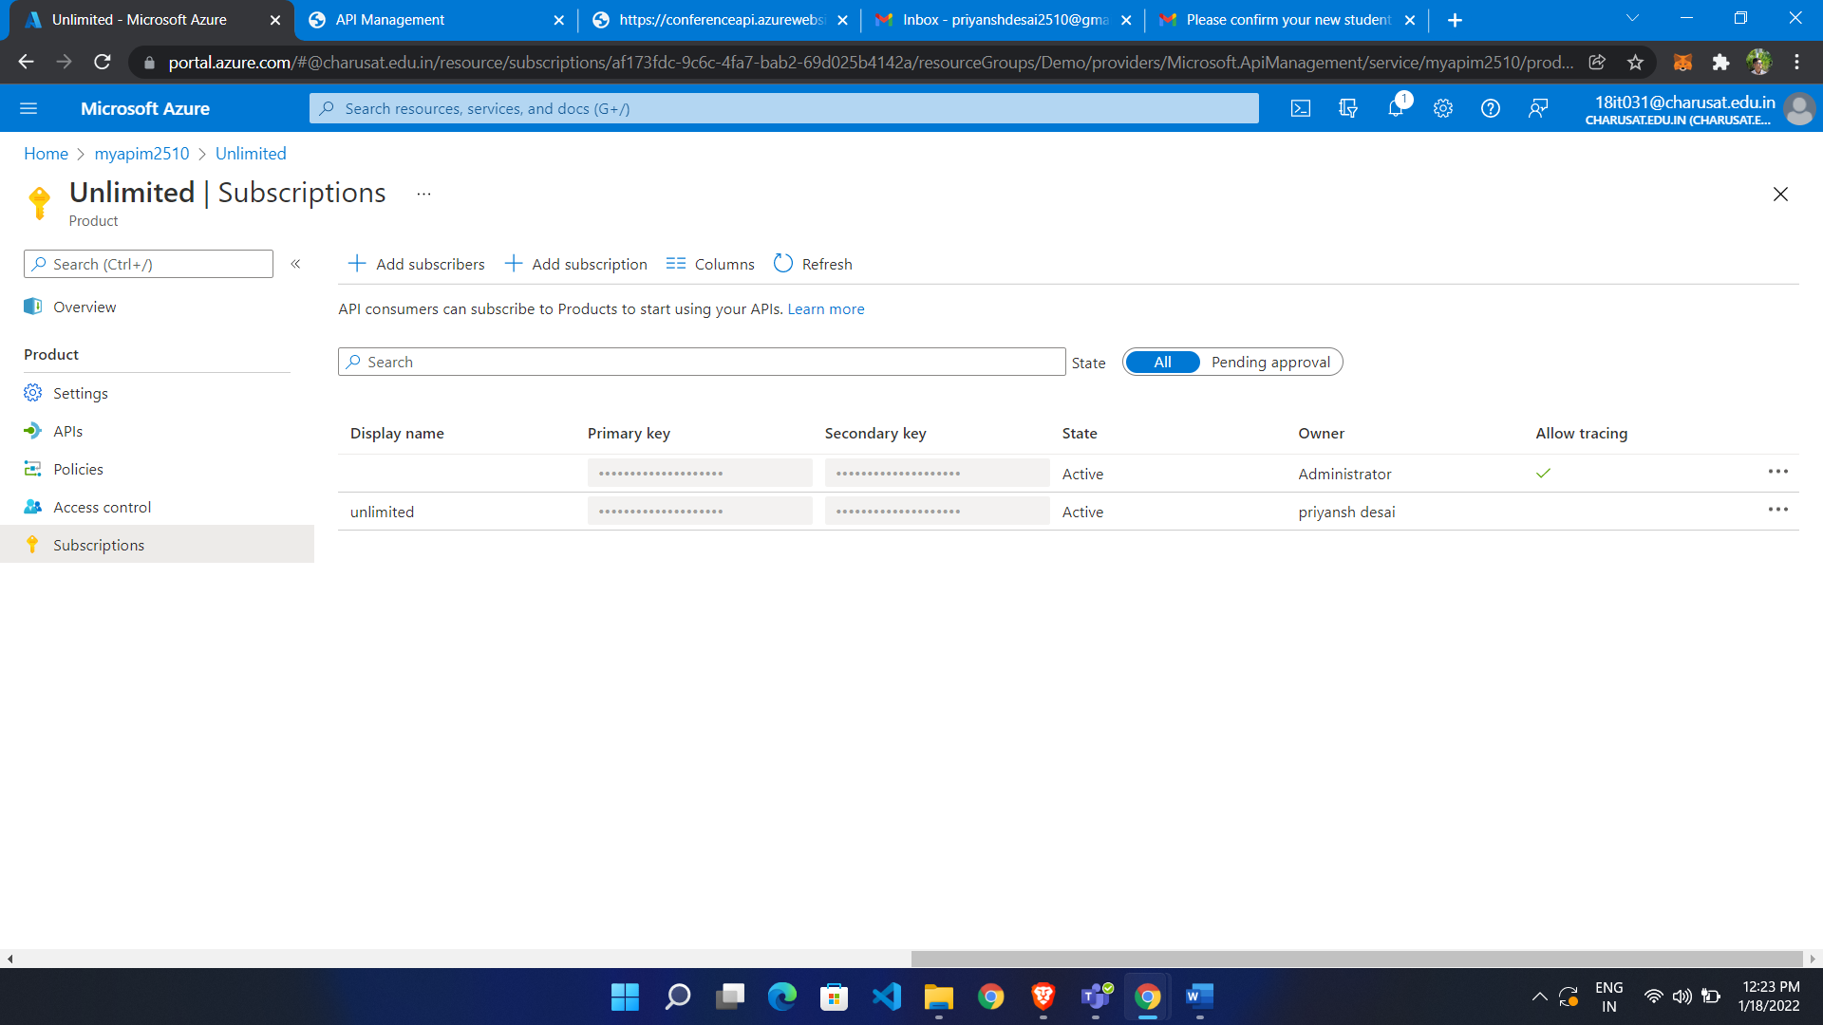

Both activated

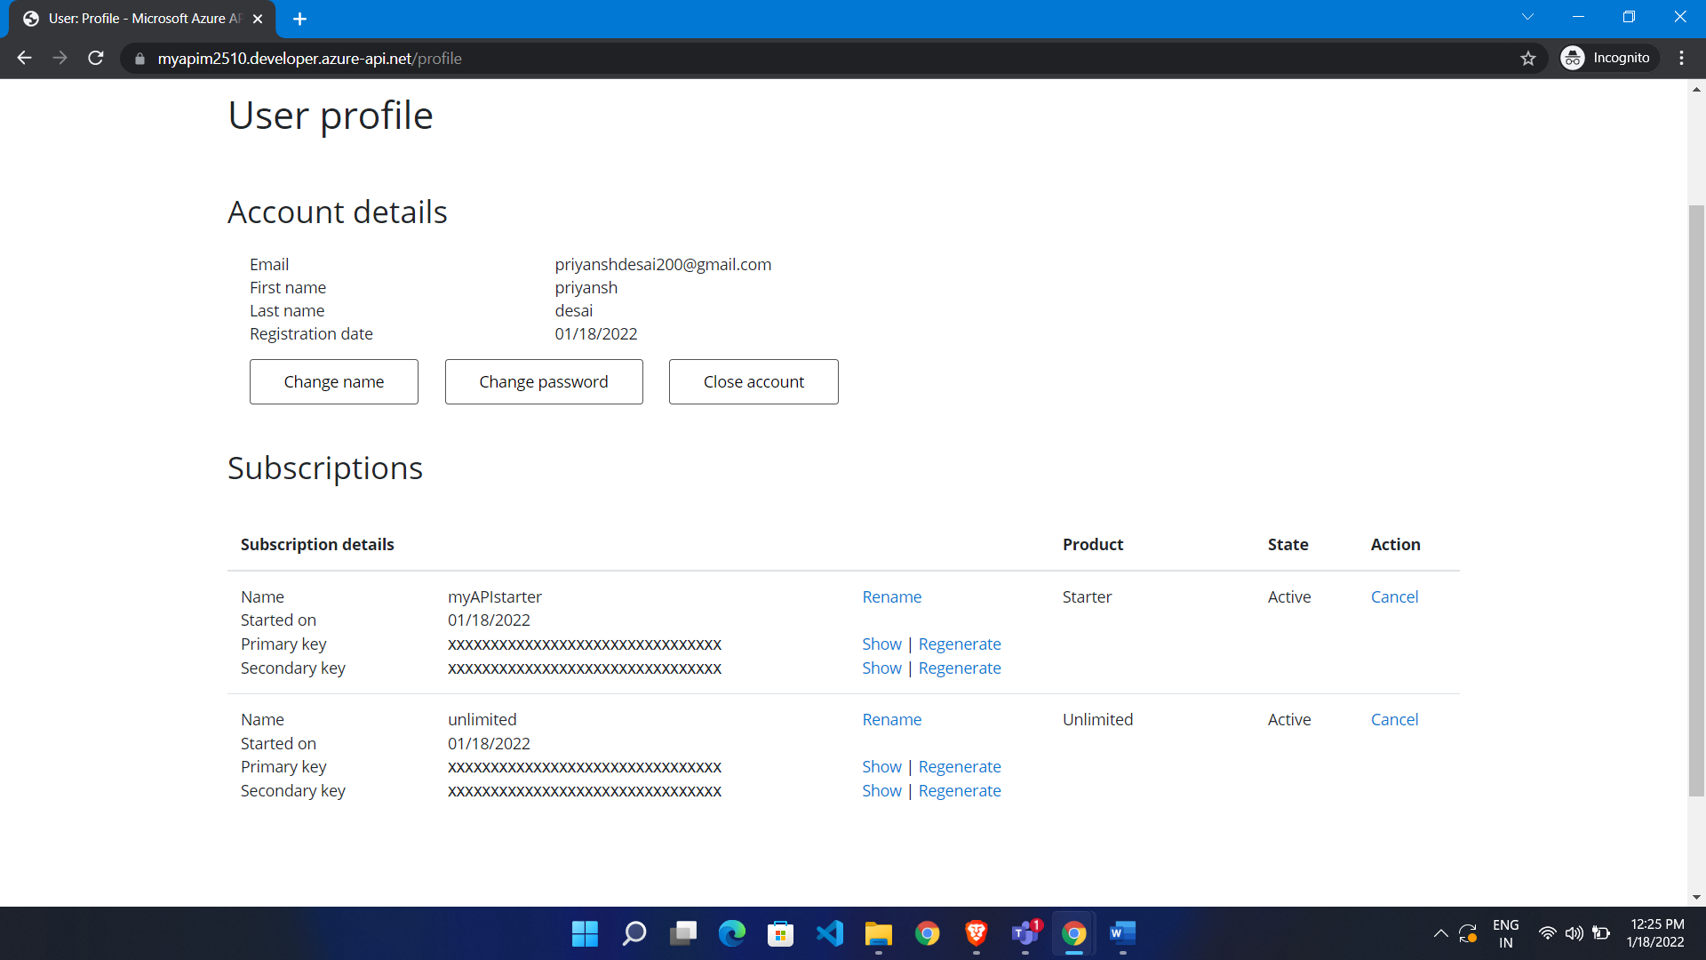

Create .net app

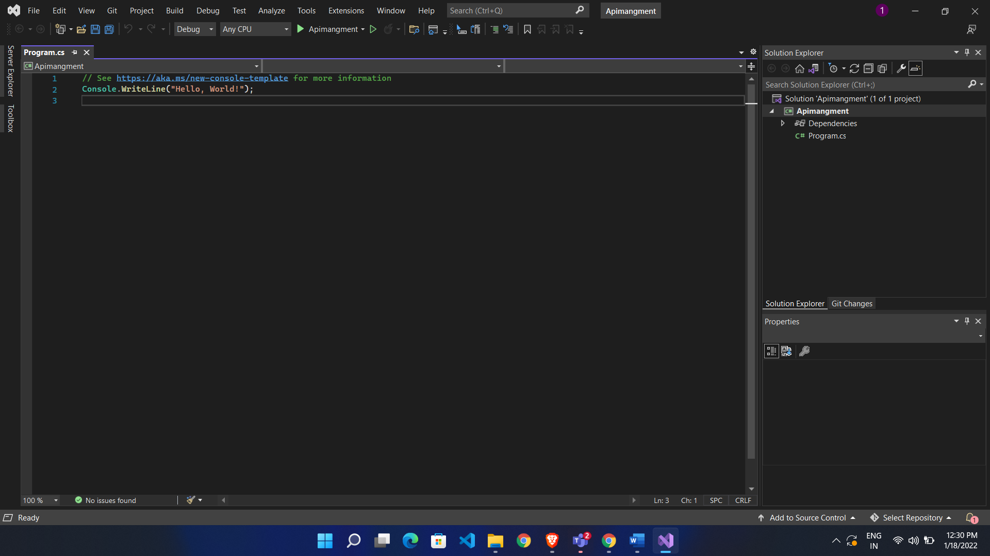

It is sample code

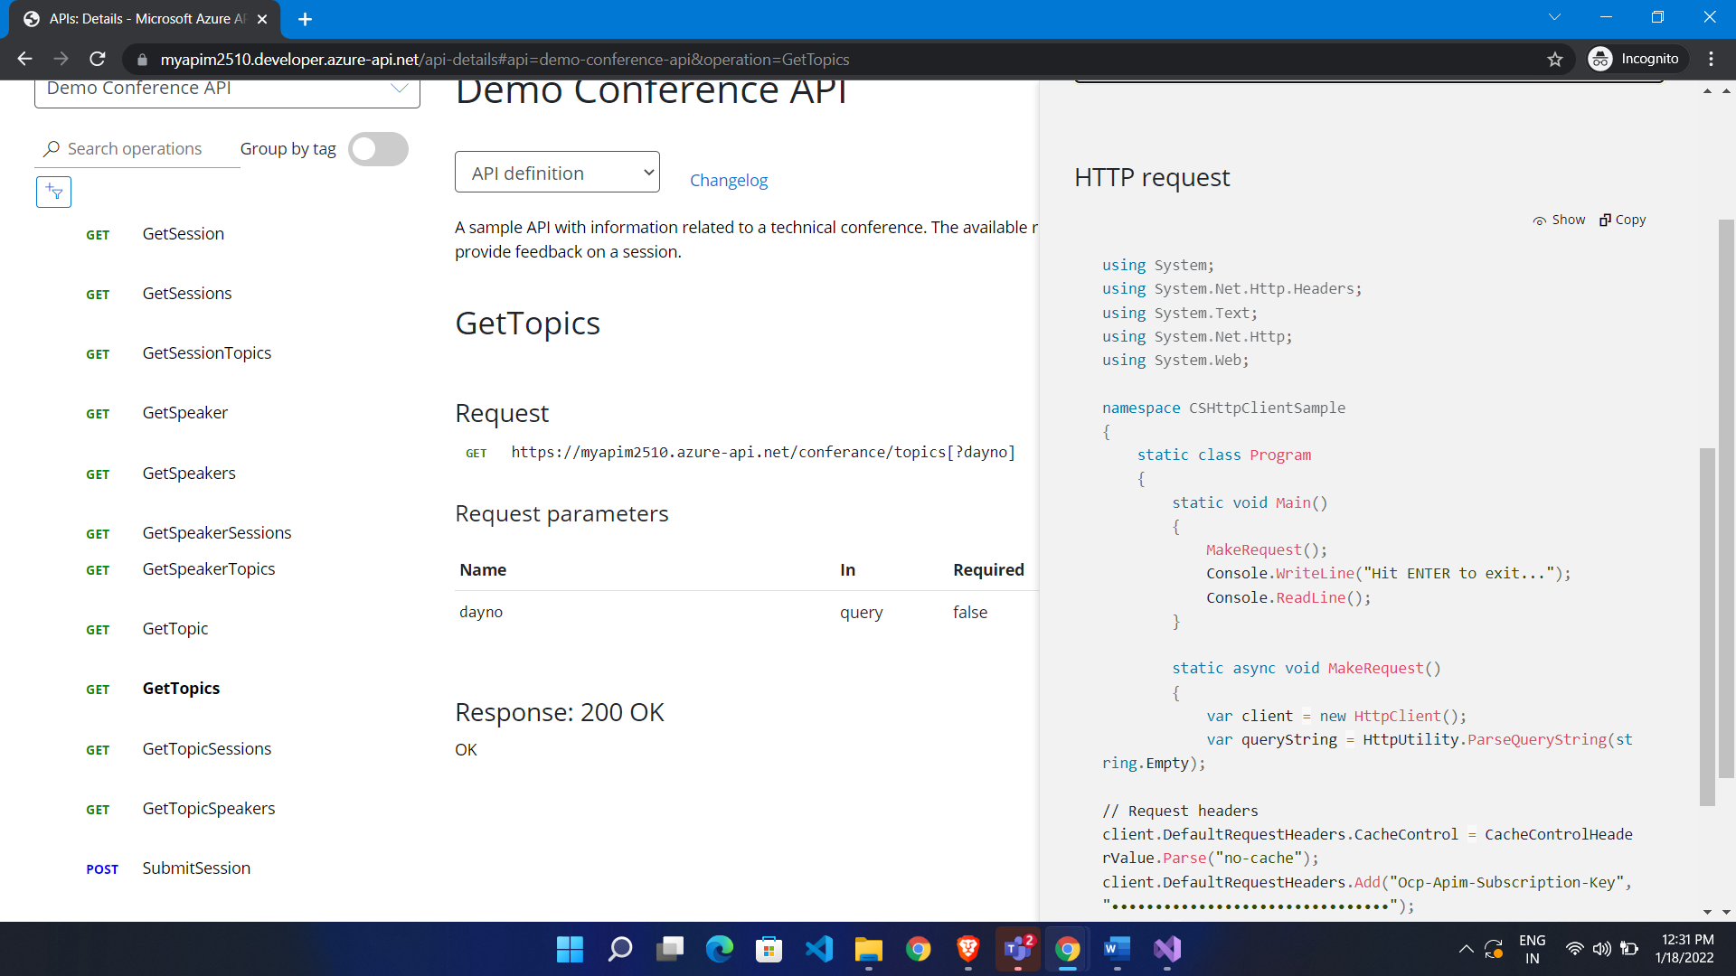

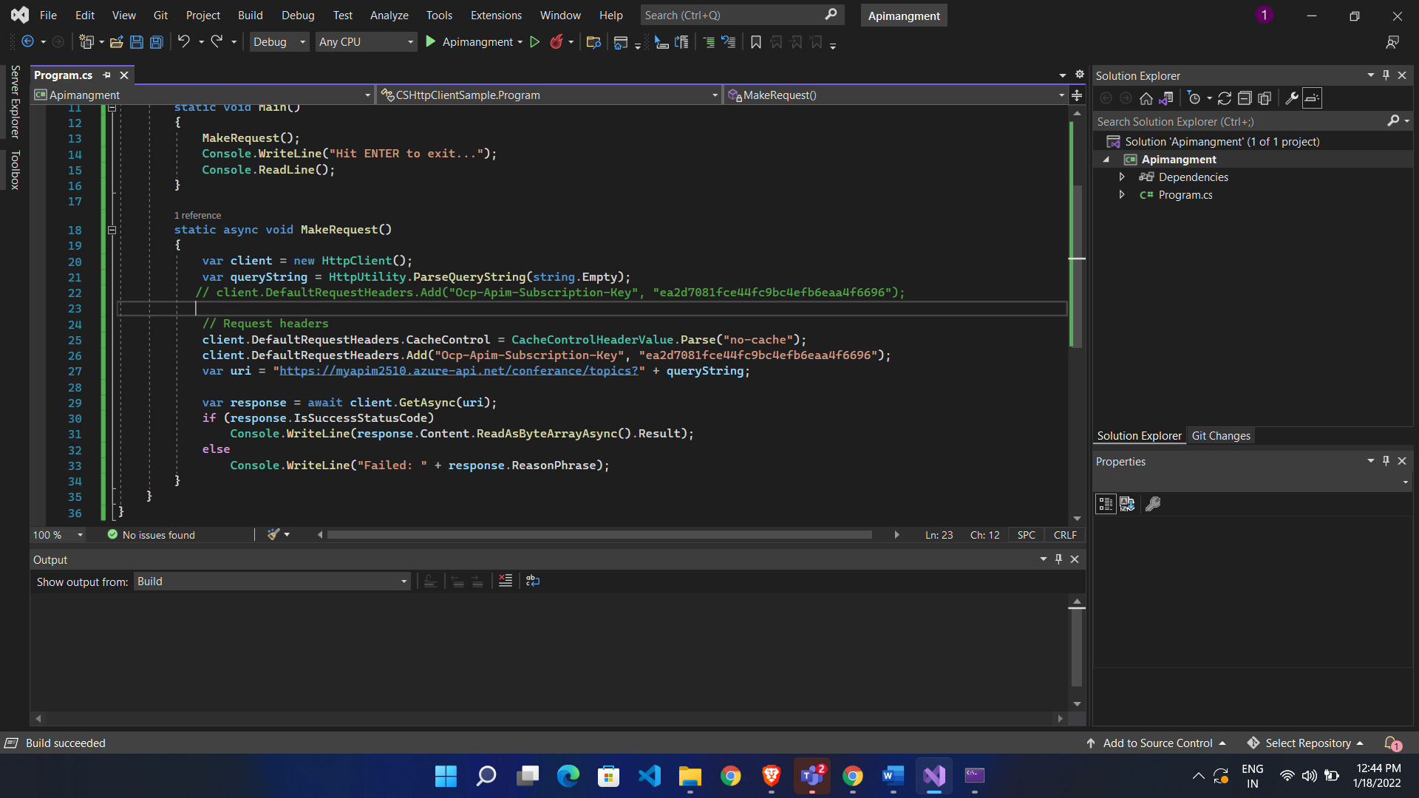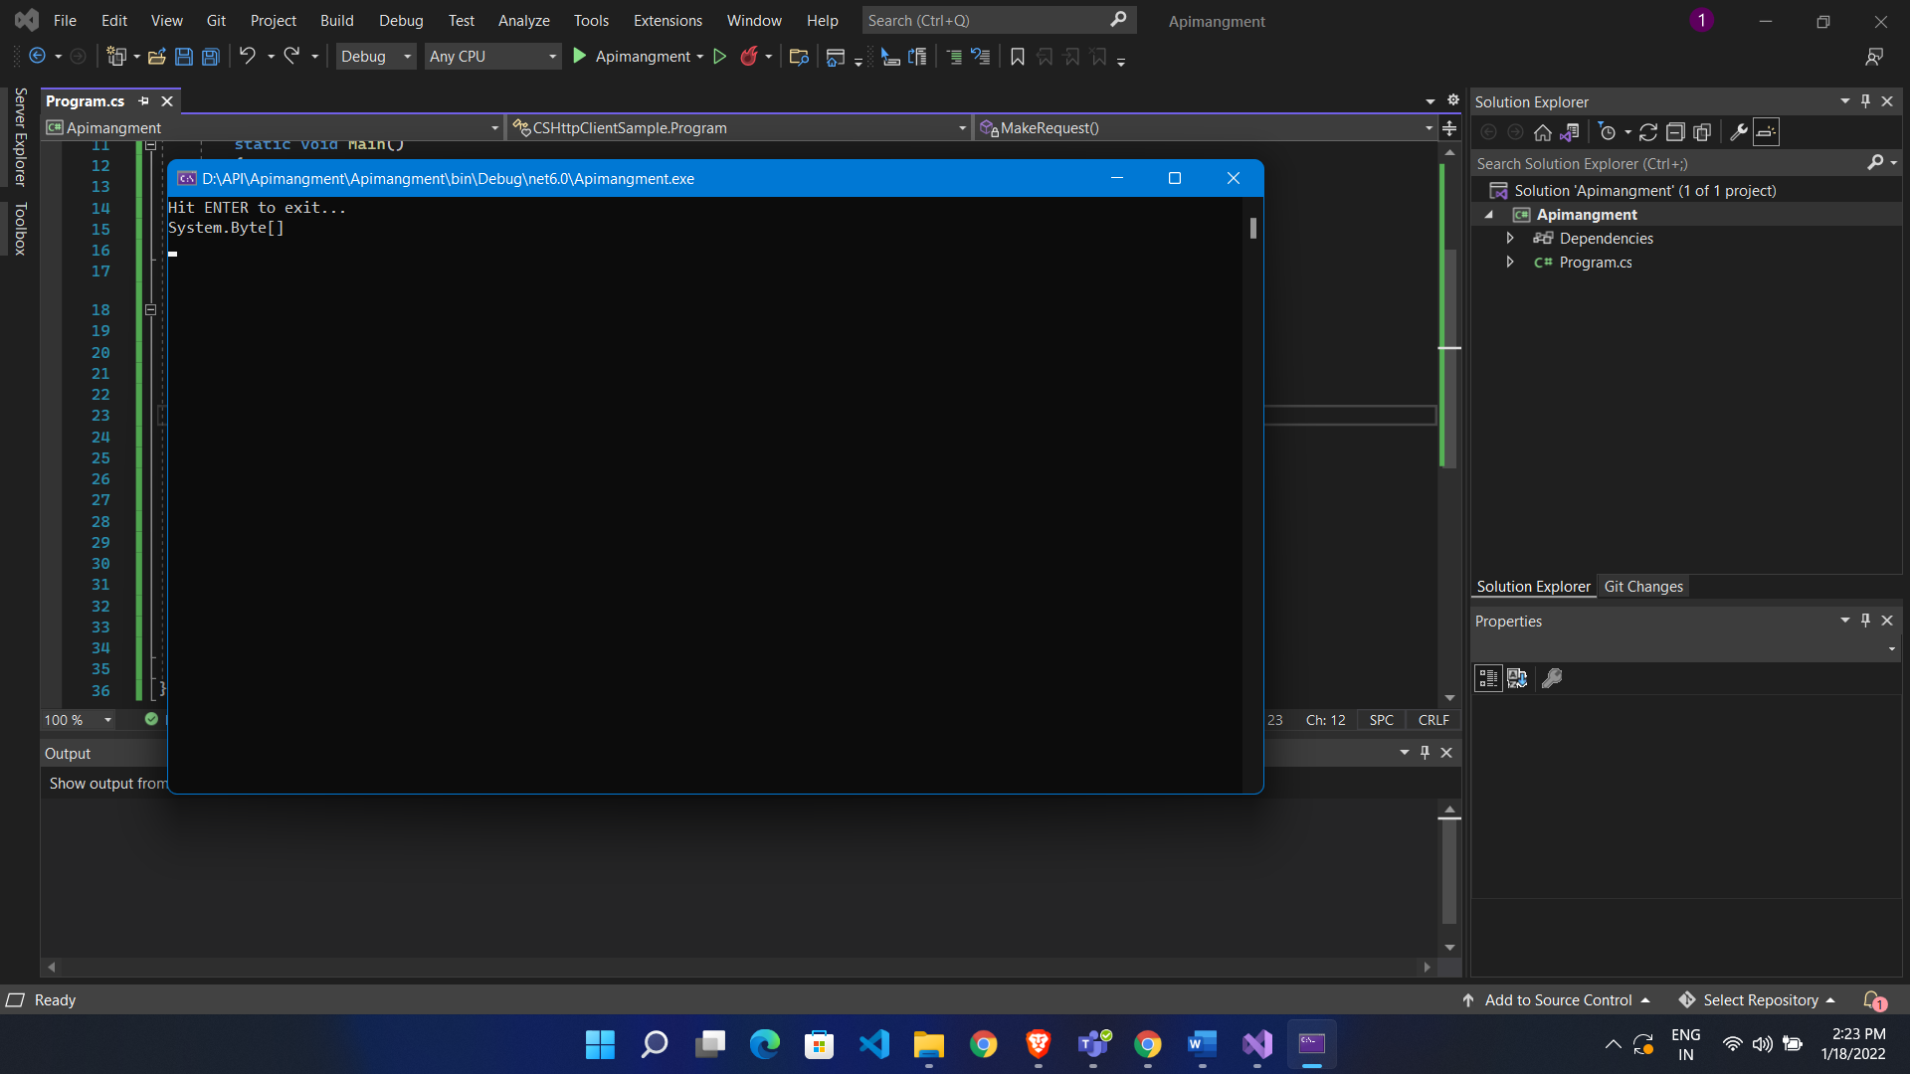

Here we use starter product so

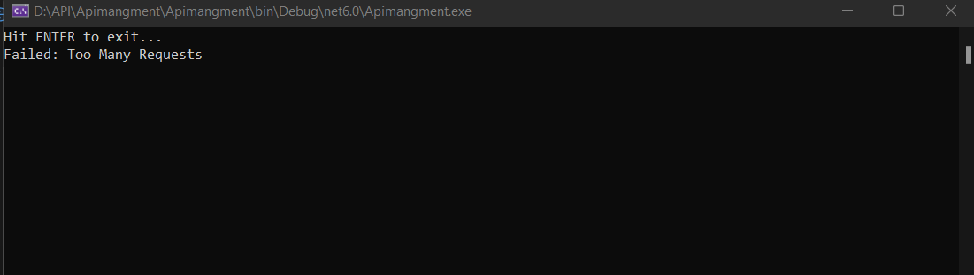

Here we learn how user can give access to API via product and subscription

Now we see how restriction can be given:

Policy’s are inbound ,outbound ,backend ,on error policy

Product level policy and api level policy

Add it to API LEVEL

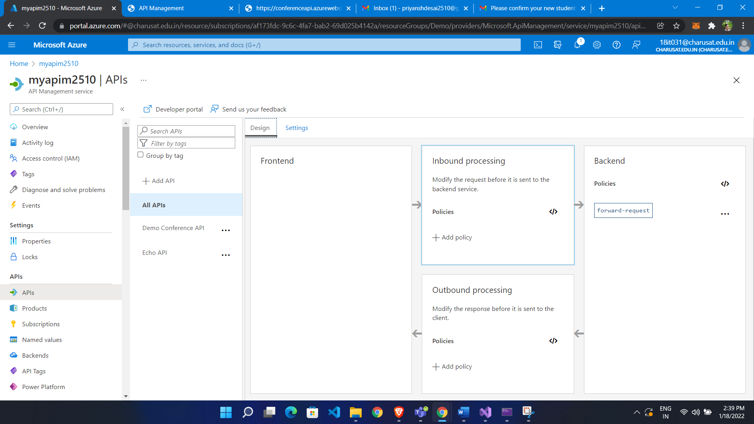

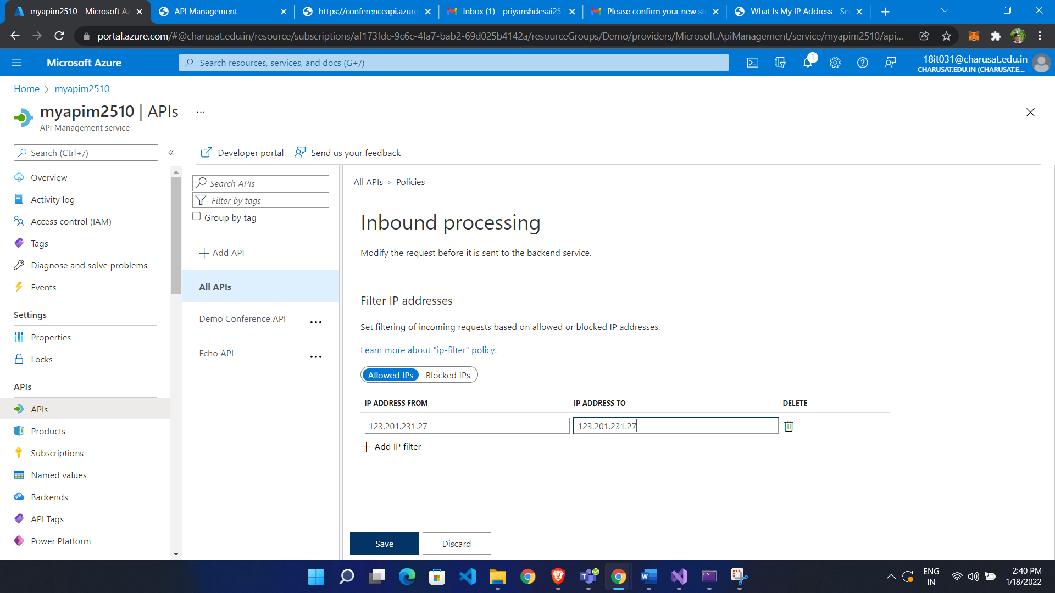

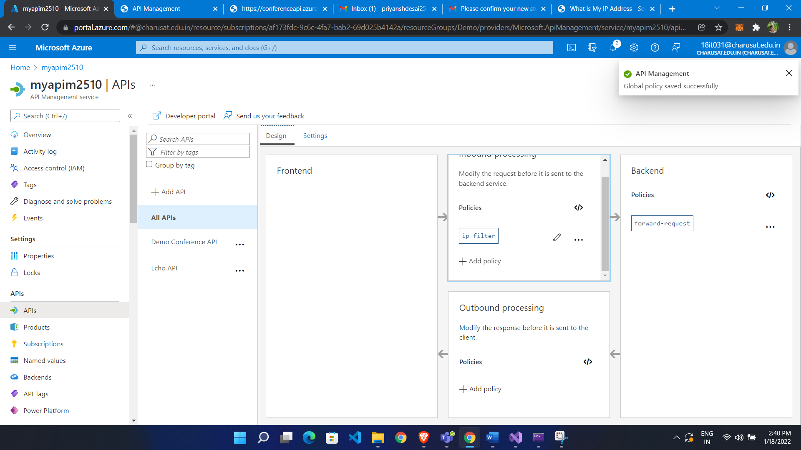

Now we are not able to access API through this ip machine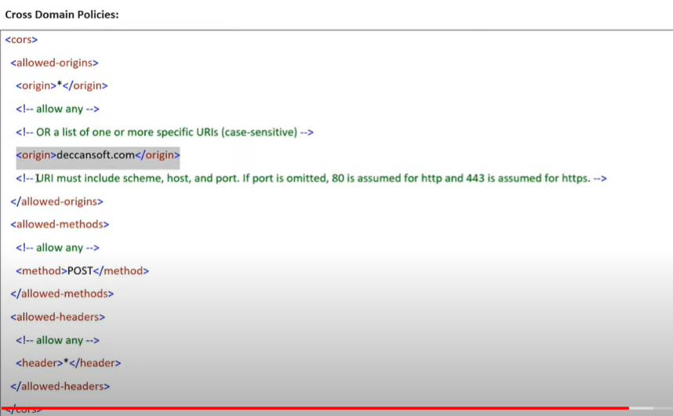

Transformation policy:

Now we have to stop render header

Go to particular api

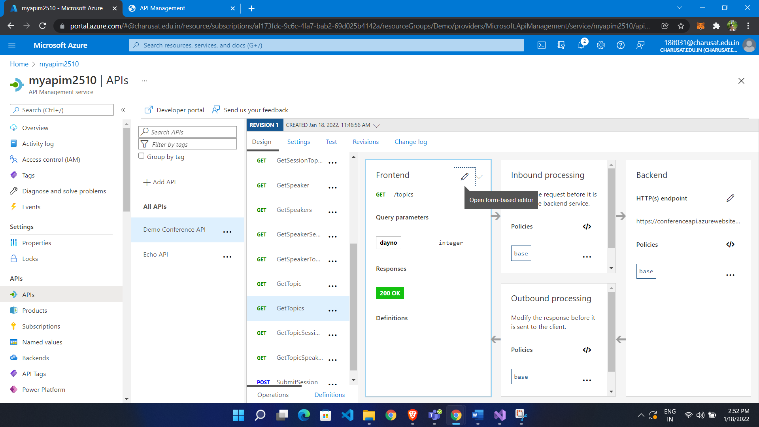

Set policy to outbound

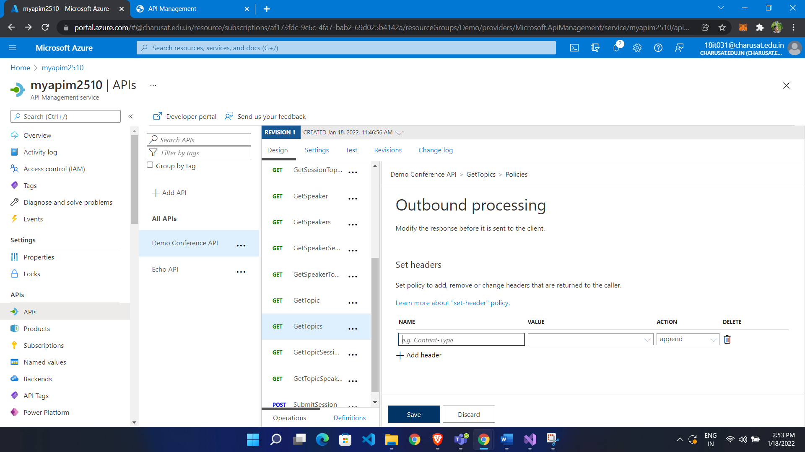

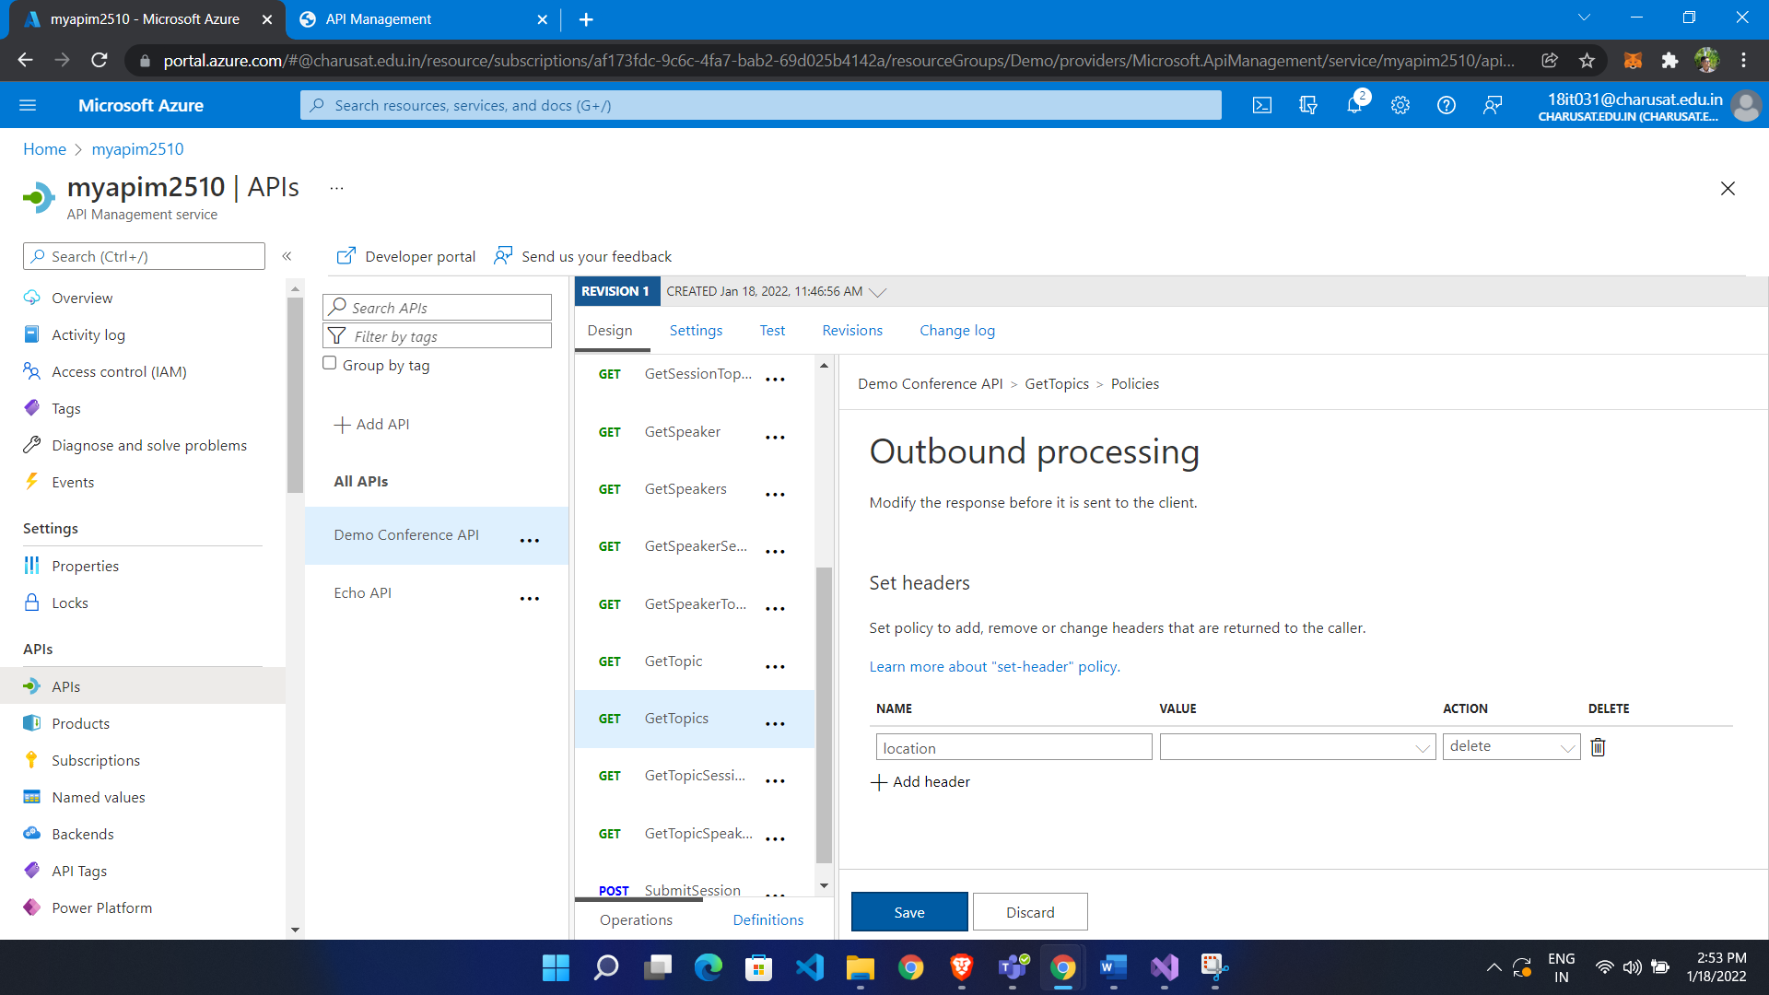

Order execution policy:

**Validate JWT token:**

How to create JWT Token and how to validate:

JWT token made up with 3 A.B.C

A is Header

B is Payload

C is encrypted Has key